**Year 8 Chemistry Test**

Student Name: Sydney Thompson

Goals:

* Sydney can draw, describe and identify examples of solids, liquids and gases.
* Sydney can determine the volume being held in a measuring cylinder.
* Sydney can give the symbol/name for most of the first 20 elements
* Sydney can identify elements, compounds and mixtures.

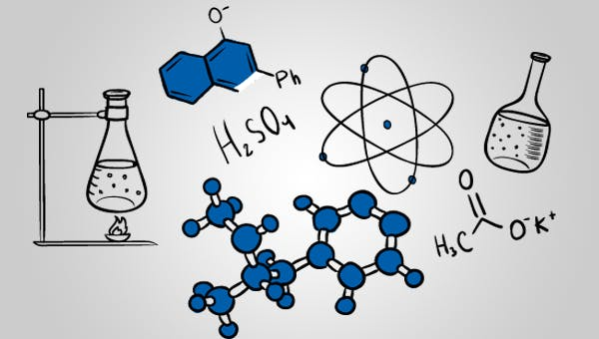

Teacher comment:

**Question 1**

**Question 2**

**Question 3**

**Question 4**

Identify the change of state that is happening in each situation:

**Question 5**

In each box, write the change of state that is taking place:

Words:

**Question 6**

For each property, explain why it is possible in terms of how the particles are arranged:

**Question 7**

**Question 8**

1. How many protons, neutrons and electrons do each of the following atoms have?
2. For an extra challenge: Can you work out the atomic number and the atomic mass. Remember – the atomic number is number of protons in the nucleus, while the mass number is the number of protons plus the number of neutrons.
3. Can you identify which elements each atom belongs to?

**Question 9**

Complete the table by giving the element name or symbol where appropriate.

**Question 10**

For the following question, circle the correct box.

Which of the boxes contains:

a) Molecules of an element?

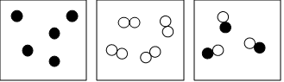

b) Molecules of a compound?

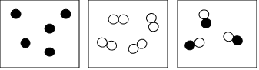

c) Atoms of an element?

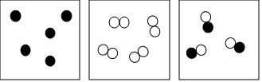

**End of Test**